Docker Compose Lab Manual
PostgreSQL Database + .NET Web API with Health Check, depends_on, Network, and Volume
Student Hands-on Lab · From Scratch
Lab Goal
Students will build and run a two-container application using Docker Compose: a PostgreSQL database container and a .NET Web API container. The API waits for the database health check before starting, and both services communicate on a custom Docker network.

What students will learn
Compose file structure, service names, container networking, health checks, depends_on, volumes, environment variables, and useful commands.

Business scenario
A Customer API stores customer records in PostgreSQL. Both services must run together consistently on every developer machine.

1. Prerequisites
- Docker Desktop installed and running
- .NET 8 SDK installed
- Basic terminal knowledge
- A code editor such as Visual Studio 2022 or VS Code
docker version
docker compose version
dotnet --version
Expected Result
All commands should return version information. If docker compose version fails, update Docker Desktop.
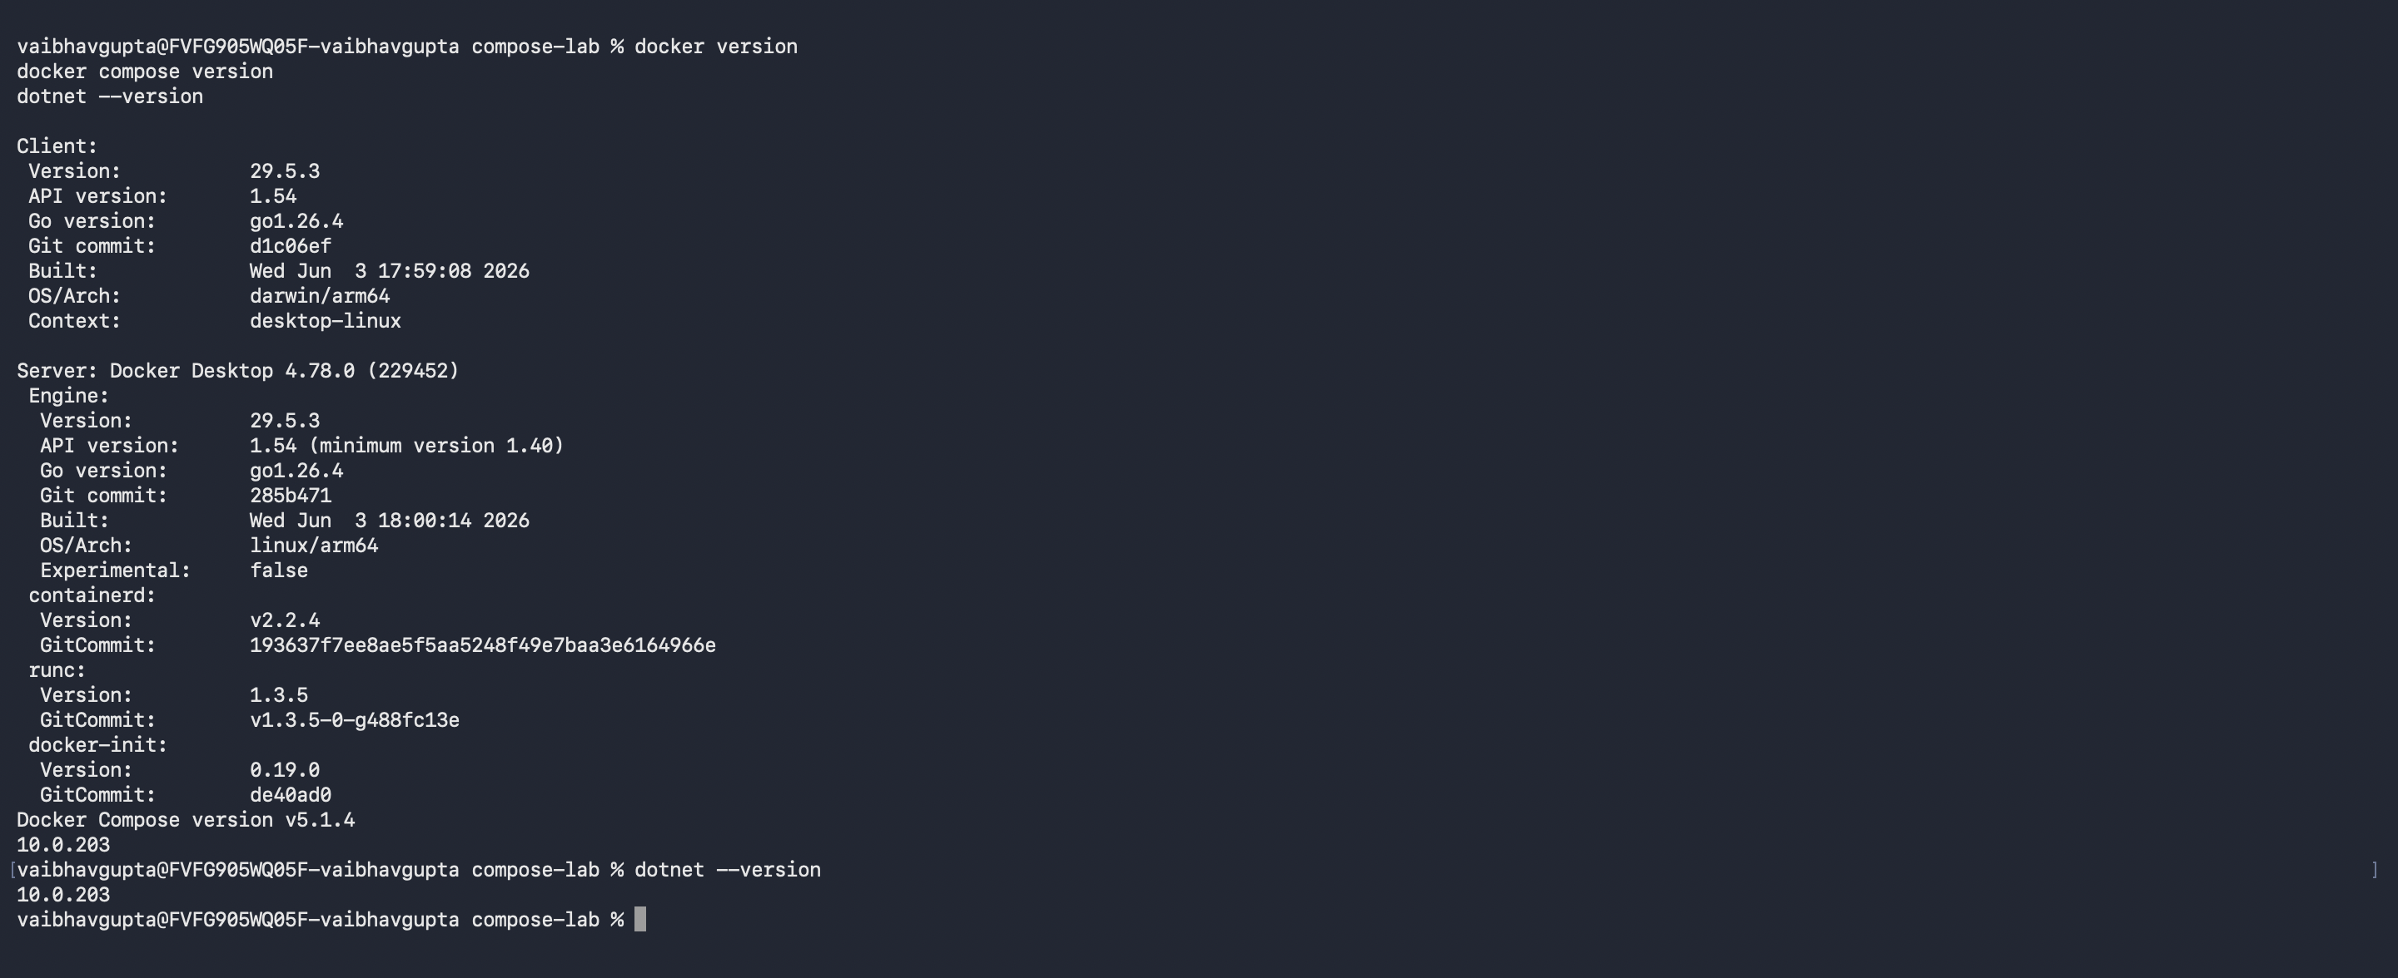

2. Final Architecture
Browser / Postman
|
| http://localhost:8080
v
.NET Web API container (service name: api)
|
| Host=postgres;Port=5432
v
PostgreSQL container (service name: postgres)
|
v
Docker named volume: postgres-data
Key Concept
Inside Docker Compose, service names become DNS host names. The API connects to the database using Host=postgres, not Host=localhost.

3. Create the Project Folder
mkdir compose-postgres-api-lab
cd compose-postgres-api-lab
dotnet new webapi -n CustomerApi --no-openapi
cd CustomerApi
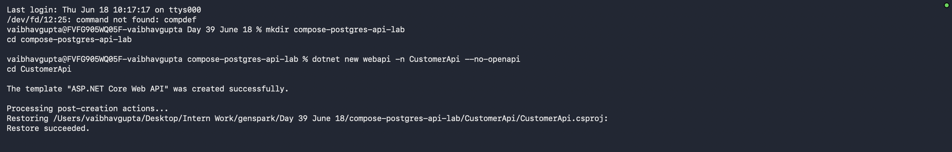

4. Add PostgreSQL and EF Core Packages
dotnet add package Npgsql.EntityFrameworkCore.PostgreSQL
dotnet add package Microsoft.EntityFrameworkCore.Design
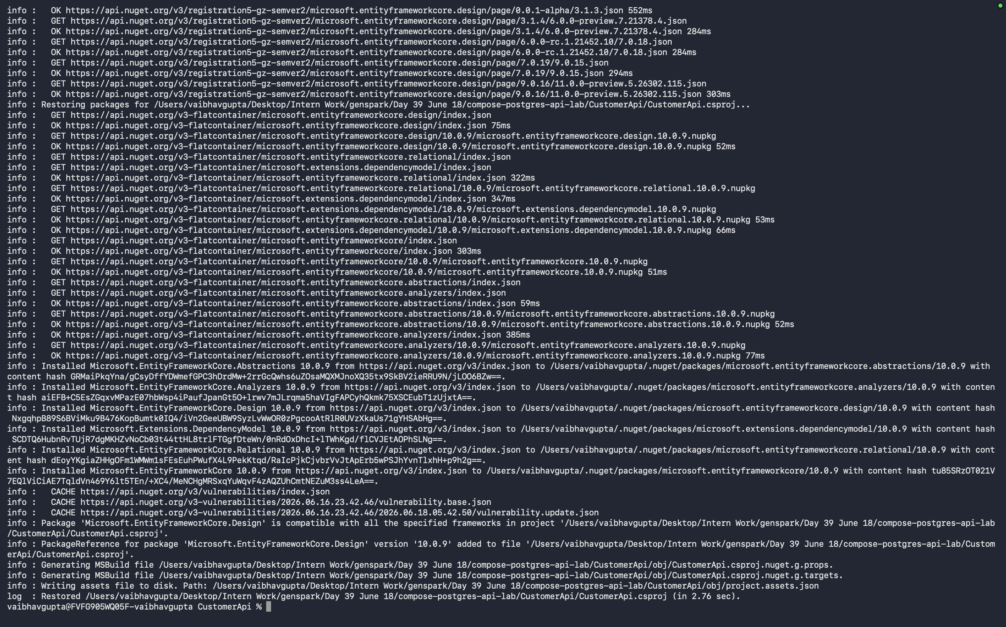

5. Add Customer Model
Create a folder named Models and add Customer.cs.
mkdir Models
// Models/Customer.cs
namespace CustomerApi.Models;
public class Customer
{
public int Id { get; set; }
public string Name { get; set; } = string.Empty;
public string Email { get; set; } = string.Empty;
}

6. Add DbContext
Create a folder named Data and add CustomerDbContext.cs.
mkdir Data
// Data/CustomerDbContext.cs
using CustomerApi.Models;
using Microsoft.EntityFrameworkCore;
namespace CustomerApi.Data;
public class CustomerDbContext : DbContext
{
public CustomerDbContext(DbContextOptions<CustomerDbContext> options)
: base(options)
{
}
public DbSet<Customer> Customers => Set<Customer>();
}

7. Replace Program.cs
This minimal API includes health endpoints and simple customer insert/read endpoints.
using CustomerApi.Data;
using CustomerApi.Models;
using Microsoft.EntityFrameworkCore;
var builder = WebApplication.CreateBuilder(args);
builder.Services.AddDbContext<CustomerDbContext>(options =>
options.UseNpgsql(builder.Configuration.GetConnectionString("DefaultConnection")));
builder.Services.AddHealthChecks();
var app = builder.Build();
app.MapHealthChecks("/health");
app.MapGet("/", () => "Customer API is running");
app.MapGet("/customers", async (CustomerDbContext db) =>
await db.Customers.ToListAsync());
app.MapPost("/customers", async (Customer customer, CustomerDbContext db) =>
{
db.Customers.Add(customer);
await db.SaveChangesAsync();
return Results.Created($"/customers/{customer.Id}", customer);
});
// For lab simplicity only. In real enterprise applications, use migrations in CI/CD.
using (var scope = app.Services.CreateScope())
{
var db = scope.ServiceProvider.GetRequiredService<CustomerDbContext>();
db.Database.Migrate();
}
app.Run();

8. Configure appsettings.json
For Docker Compose, the database host is the service name postgres.
{
"ConnectionStrings": {
"DefaultConnection": "Host=postgres;Port=5432;Database=customerdb;Username=postgres;Password=postgres"
},
"Logging": {
"LogLevel": {
"Default": "Information",
"Microsoft.AspNetCore": "Warning"
}
},
"AllowedHosts": "*"
}

9. Create Dockerfile for .NET Web API
Create a file named Dockerfile inside the CustomerApi folder.
# Stage 1: Build
FROM mcr.microsoft.com/dotnet/sdk:8.0 AS build
WORKDIR /src
COPY CustomerApi.csproj .
RUN dotnet restore
COPY . .
RUN dotnet publish -c Release -o /app/publish --no-restore
# Stage 2: Runtime
FROM mcr.microsoft.com/dotnet/aspnet:8.0 AS runtime
WORKDIR /app
COPY --from=build /app/publish .
ENV ASPNETCORE_URLS=http://+:8080
EXPOSE 8080
ENTRYPOINT ["dotnet", "CustomerApi.dll"]

10. Create .dockerignore
bin/
obj/
.git/
.vs/
.vscode/
*.user
Dockerfile*
docker-compose*.yml
.dockerignore

11. Create EF Core Migration
Run from the CustomerApi folder.
dotnet tool install --global dotnet-ef
# If already installed, update it:
# dotnet tool update --global dotnet-ef
dotnet ef migrations add InitialCreate
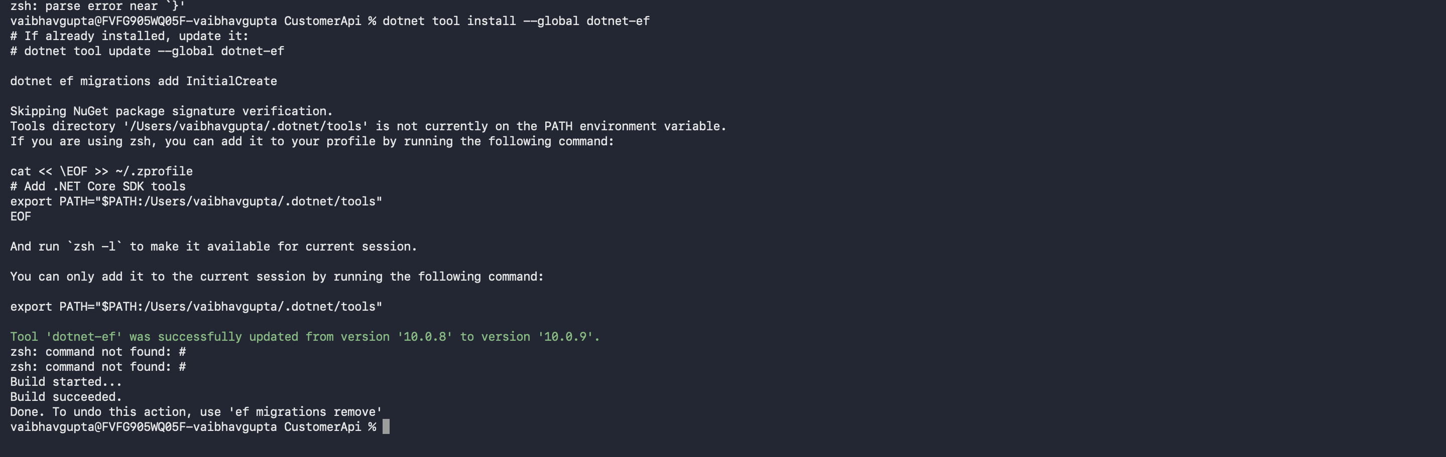

12. Create docker-compose.yml
Go back to the root folder compose-postgres-api-lab and create docker-compose.yml.
cd ..
services:
postgres:
image: postgres:16
container_name: compose-postgres-db
environment:
POSTGRES_DB: customerdb
POSTGRES_USER: postgres
POSTGRES_PASSWORD: postgres
ports:
- "5432:5432"
volumes:
- postgres-data:/var/lib/postgresql/data
healthcheck:
test: ["CMD-SHELL", "pg_isready -U postgres -d customerdb"]
interval: 10s
timeout: 5s
retries: 5
start_period: 10s
networks:
- backend-network
api:
build:
context: ./CustomerApi
dockerfile: Dockerfile
container_name: compose-customer-api
environment:
ASPNETCORE_ENVIRONMENT: Development
ConnectionStrings__DefaultConnection: Host=postgres;Port=5432;Database=customerdb;Username=postgres;Password=postgres
ports:
- "8080:8080"
depends_on:
postgres:
condition: service_healthy
networks:
- backend-network
volumes:
postgres-data:
networks:
backend-network:
driver: bridge
Why depends_on with condition?
The API starts only after the postgres service reports healthy. The health check uses pg_isready to verify PostgreSQL is accepting connections.

13. Execute the Lab
# Build and start all services
cd compose-postgres-api-lab
docker compose up --build
To run in the background:
docker compose up --build -d
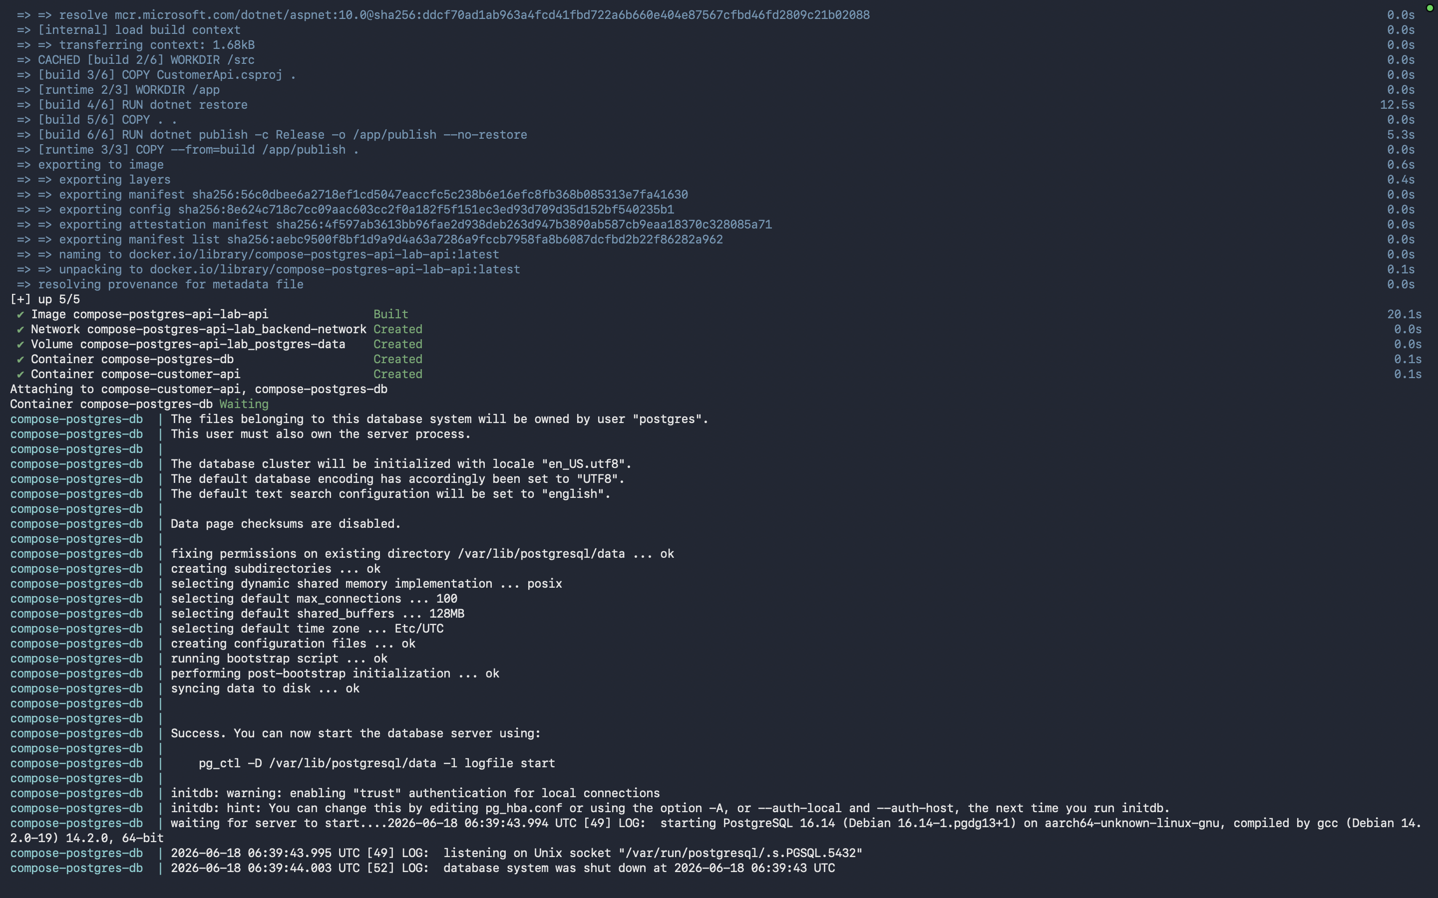

14. Verify Containers
docker compose ps
Expected: postgres should be healthy and api should be running.
docker compose logs postgres
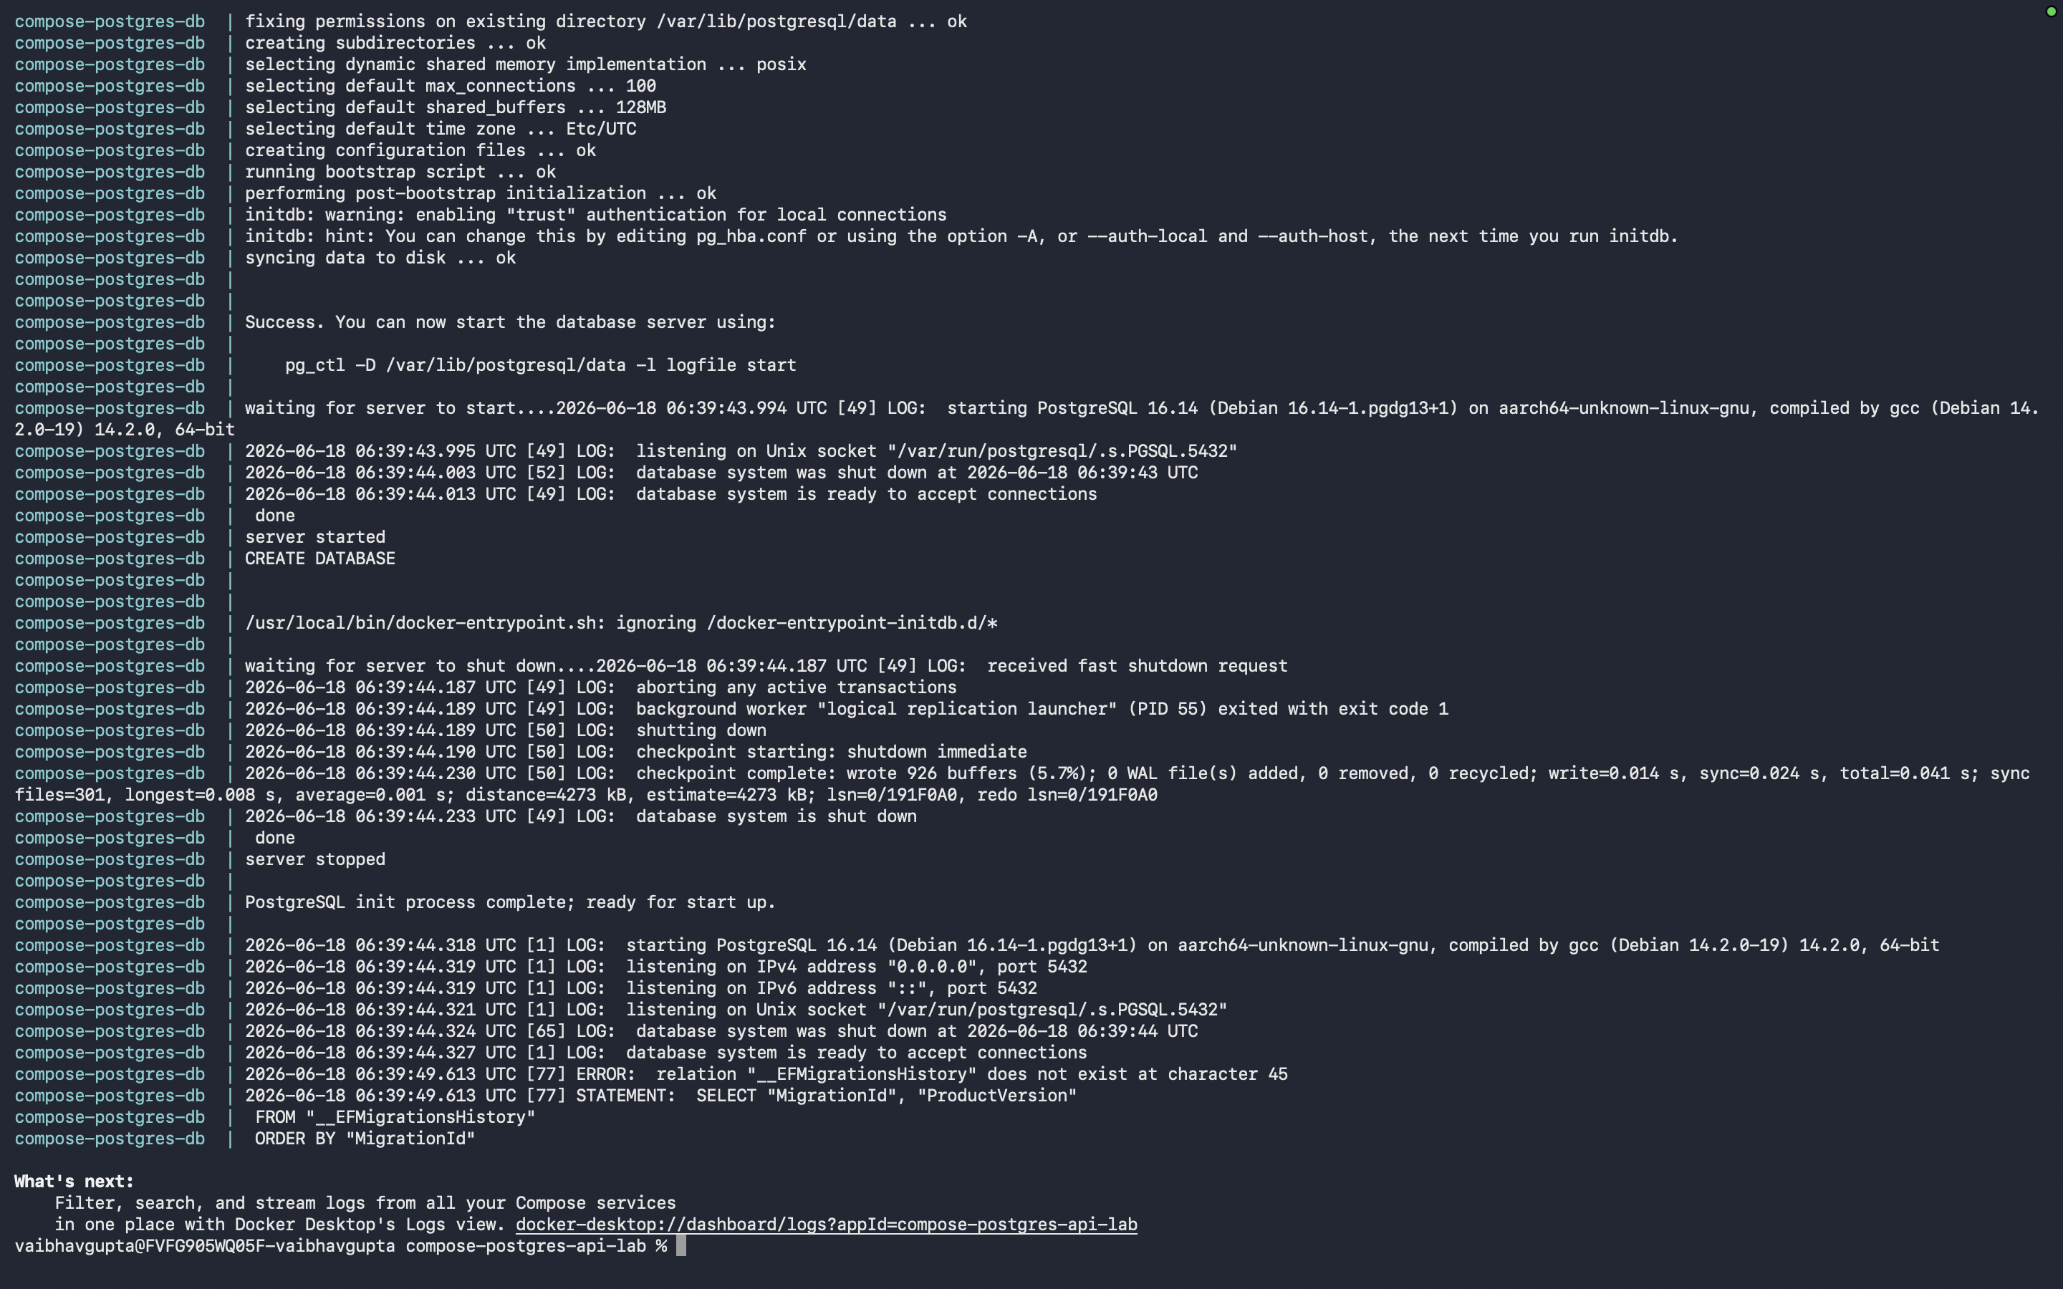
docker compose logs api
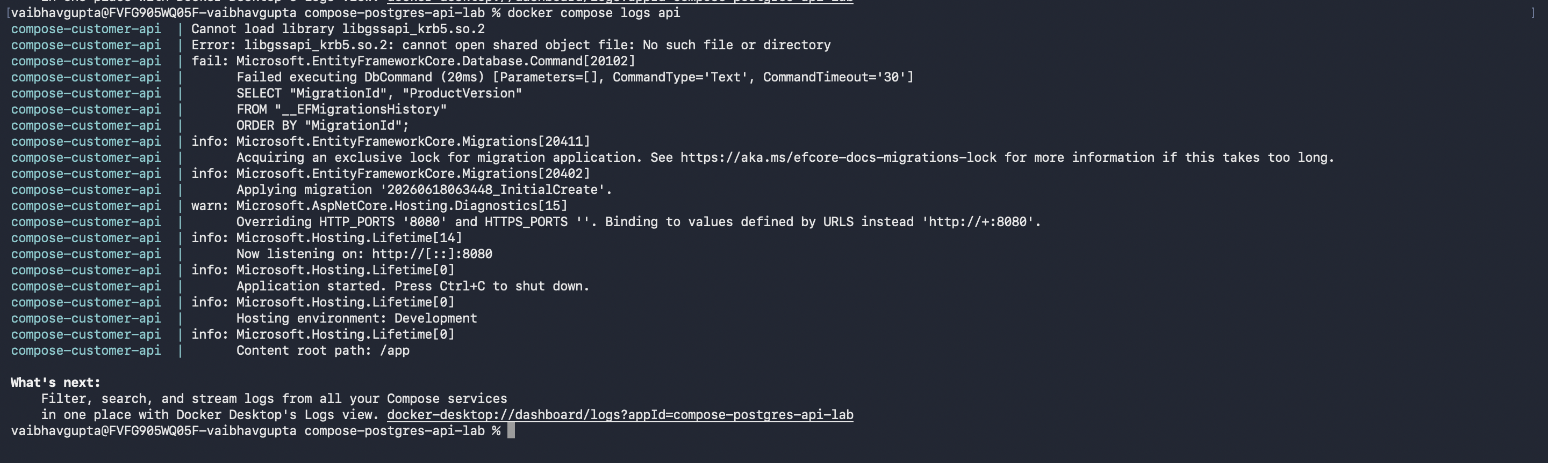

15. Test the API
curl http://localhost:8080/
curl http://localhost:8080/health
Create a customer:
curl -X POST http://localhost:8080/customers -H "Content-Type: application/json" -d "{"name":"Gayathri","email":"gayathri@example.com"}"
Read customers:
curl http://localhost:8080/customers

16. Optional: Check PostgreSQL Directly
docker exec -it compose-postgres-db psql -U postgres -d customerdb
\dt
SELECT * FROM "Customers";
\q

17. Compose File Explanation
Compose Section | Meaning
services | Defines the containers to run.
postgres | The PostgreSQL database service.
api | The .NET Web API service.
environment | Passes configuration values into containers.
ports | Maps host machine ports to container ports.
volumes | Persists PostgreSQL data outside the container.
healthcheck | Checks whether PostgreSQL is ready.
depends_on | Starts the API only after PostgreSQL is healthy.
networks | Places both services on the same Docker network.

18. Troubleshooting Guide

API cannot connect to database
Check the connection string. Inside Compose use Host=postgres, not Host=localhost.

postgres is unhealthy
Run docker compose logs postgres and verify username, password, and database name.

Port already in use
Change the left side of the port mapping, for example 5433:5432 or 8081:8080.

Migration fails
Check that the EF migration folder exists and the API has Npgsql package installed.

Data not deleted after compose down
Named volumes persist by default. Use docker compose down -v only when you want to delete data.

19. Useful Docker Compose Commands
Command | Purpose
docker compose up --build | Build and start services in foreground.
docker compose up --build -d | Build and start services in background.
docker compose ps | Show service status.
docker compose logs api | Show API logs.
docker compose logs postgres | Show database logs.
docker compose restart api | Restart only API service.
docker compose down | Stop and remove containers and network. Keeps volumes.
docker compose down -v | Stop and remove containers, network, and volumes. Deletes database data.

20. Student Assignment
- Change the API external port from 8080 to 8081 and test it.
- Add another customer using curl or Postman.
- Run docker compose down and then docker compose up -d. Verify data still exists.
- Run docker compose down -v and explain why data is gone.
- Change the database password and update the API connection string accordingly.

21. Knowledge Check
Q: Why does the API use Host=postgres?
A: Because postgres is the Docker Compose service name and Compose DNS resolves it.
Q: What does the PostgreSQL health check do?
A: It verifies that PostgreSQL is ready to accept connections.
Q: What does depends_on condition: service_healthy mean?
A: The API service waits until the database health check passes before starting.
Q: What happens to data when docker compose down is used?
A: Containers and network are removed, but named volumes remain.
Q: What command deletes database data?
A: docker compose down -v

